# Unit #1 Homework

I do not have a hard copy of the book, but the PDF version. As confirmed with Professor, I am attaching the snapshots to the document.

## Homework 1:2 Cardinal Numbers (pg7)

## Homework 1:3 Fingerspelling Names (pg13)

## Homework 1:6 Cardinal Numbers 11-15 (pg22)

## Homework 1:7 Fist Letter Names (pg24)

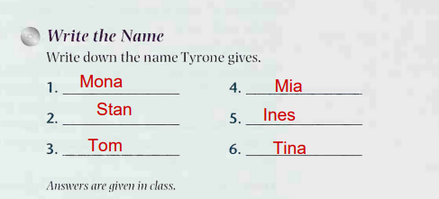

## Homework 1:8 Identify a Person, mini dialogues (pg27)

## Homework 1:9 Inside, Above, Below (Pg 29)

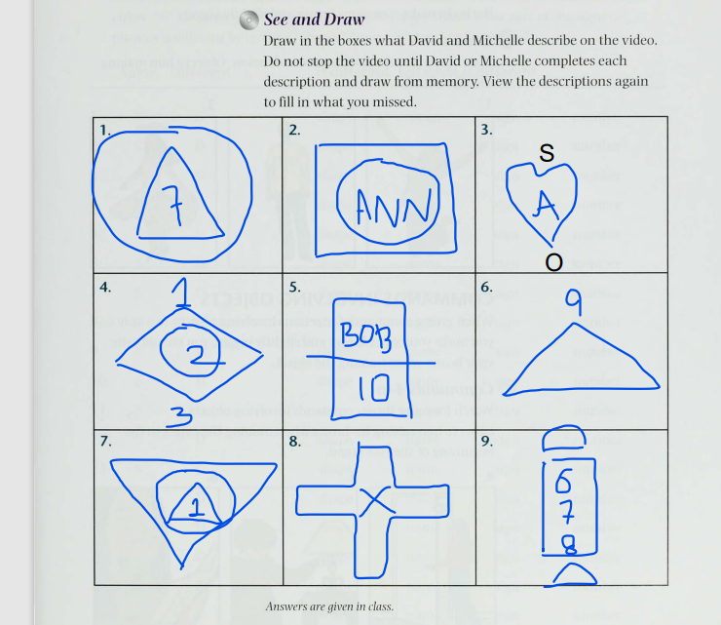

## Homework 1:11 Test your Eye-Q; Picture It (Pg32)

